The Worship of Our God
Resting in the Renewing Power of God’s Grace

October 25, 2026 - 9am

Welcome

Call to Worship How Majestic Is Your Name 2 (P)

Pastoral Prayer Followed by the Lord’s Prayer (trespasses)

Worship in Song All Hail the Power 240 (G)
Crown Him with Many Crowns 243 (G)
At the Name of Jesus 244 (G)

Offertory Prayer & Offering

Worship in Song Jesus Is All the World to Me 556 (G)

Worship in Word John 17
Worship in Word Christ - Our Intercessor!
Pastor Jeff Griffith

Worship in Song All That Thrills My Soul 563 (G)
Benediction

Postlude

Accompanists: Kathi Nelson, Phyllis Shortenhaus
(G) Green hymnal, (P) Purple chorus book (I) Insert

Welcome! We are a gathering of believers in Christ Jesus who desire to love God with all our heart, mind, soul, and strength, to love our neighbors as ourselves, and to make disciples of Christ Jesus.

Faithful in Prayer
Praises & Prayers
- God’s faithfulness in all things
- His grace in preaching, prayer, the sacraments & fellowship
- His powerful & life-giving Word
- Our church family-- individually and collectively; our pastors
- 1G Network and VBS students & families and volunteers
- Family of Tim Heitland
- Emily Silber
- Terry Elman
- Mark Beenken (home under hospice care)
- Brian Bashans
- Linda & Ron Abels 2680 Old Hwy Rd, Nashua, IA 50658
- Dorothy Berschman
- Duane Kloster 609 2nd St NE, Buffalo Center, IA 50424
- Jim & Dee Kiewiet 304 7th Ave SW, Buffalo Center, IA 50424
- Ivan Dybevik, grandson of Susan Elman Risius
- Jeff Jacobson 87803 245th St, Oakland, MN 56007
- Harold Albrandt, Alicia Burkhow
- TMNH: Kevin Stecker, Phyllis Shortenhaus, Louise Enright
- Bev Heyes
  - Mail: Paul Heyes, Attn: Beverly Heyes, 9148 Creek Way, Savage, MN 55378
- Connie Berhow

Day to Day:
- Opportunities to share the Gospel and the words to say
- Revival in self, Christ’s church, our community, state and country
- Governing authorities & our country
- Wisdom as parents & grandparents committed to raising children in the fear and instruction of the Lord; strong marriages

October Mission Partners: Don & Teleka Dewing with Midwest Indian Mission, Crandon, WI

October 28, Wednesday 3:30pm 1God. This week’s lesson is, “Abraham- The Visitors”. First Baptist Church will serve the after- school snack as well as the meal at 5:30. We had 30 students and served 67 suppers on October 21.

November 1 Planning on worshiping at TMNH at 9:15 and celebrating Kevin’s birthday right at 10am so we are out by 10:40am.

Our love and sympathy to the family of Tim Heitland who met his Savior face to face on Saturday, October 24. Please keep Joyce, Mike & Bobbie, and Josh & Jenna in your prayers.

Christian love and sympathy are extended Doris Heyes in the passing of her sister, Carol (Abels) Mitchell. May God’s peace and comfort surround her, Shirley, Ron & Linda, and Marlene & Andy.

Thank you! A special thanks for the kind and encouraging gift from the church for Pastor's Appreciation month. I continually prayer for you all, and know you pray for me as well. Pastor Gruis

Pulpit Supply
October 25 Pastor Jeff Griffith Cookie Potluck
November 1 Pastor Larry Gruis Celebrate Kevin’s Bday
November 8 Pastor Tim Diehl
November 15 Pastor Larry Gruis Thanksgiving Potluck
November 22 Pastor Larry Gruis Cookie Potluck
November 29 Pastor Jeff Griffith No coffee time
December 6 Pastor Larry Gruis
December 13 Garth or Trish Boltinghouse Donuts
December 20 Pastor Larry Gruis Cookie Potluck
December 27 Garth or Trish Boltinghouse No coffee time

Contact Information
Pastor Tim Diehl Pastor Jeff Griffith Pastor Larry Gruis
Cell (651) 325-7502 Cell (712) 209-7219 Home (641) 562-2864
diehltim@yahoo.com kralupy@gmail.com ldgruis@yahoo.com

First Congregational Church
Buffalo Center, Iowa

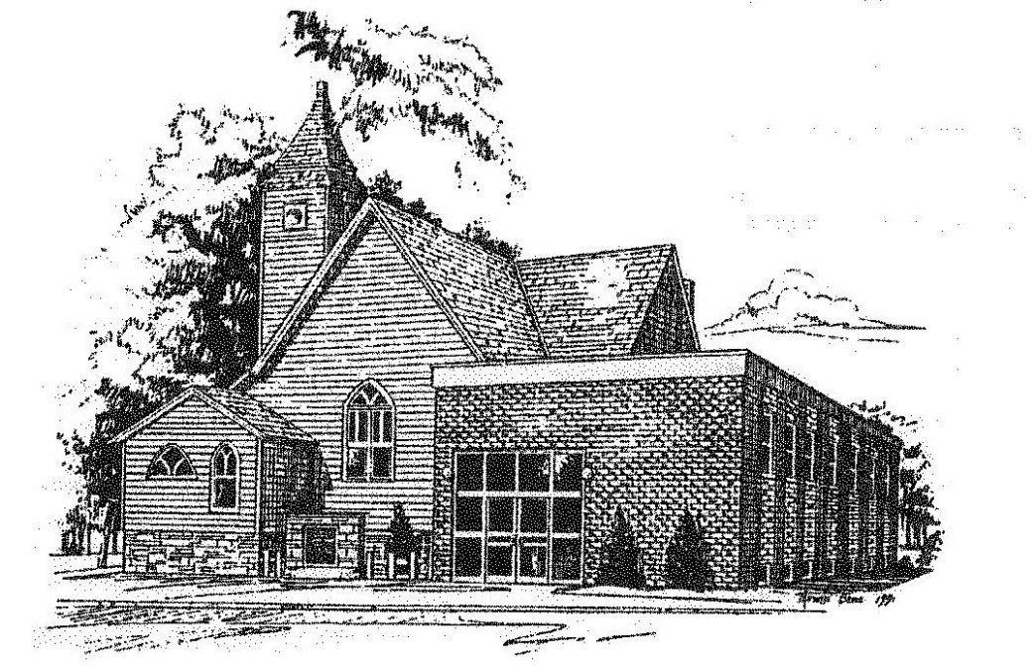

Loving God, Loving People, Making Disciples

Established in Covenant Faithfulness
September 18, 1892
Member of the
Conservative Congregational
Christian Conference
Since 1964

Member of the Conservative Congregational Christian Conference
www.firstcongocobc.com
www.ccccusa.com

