The Worship of Our God
Resting in the Renewing Power of God’s Grace

October 11, 2026 - 9am

Prelude
Welcome & Announcements
Call to Worship
Worship in Song Great is the Lord 47 (P)
All Hail King Jesus 71 (P)
Majesty 98 (P)

Pastoral Prayer, Offertory Prayer & Offering

Worship in Song Like a River Glorius 343 (G)

Reading of the Word II Timothy 1:5
II Timothy 2:8-13

Worship in Word “Fan the Flame”
Pastor Tim Diehl

Worship in Song Shine, Jesus Shine 259 (P)

Benediction

Postlude

Accompanists: Kathi Nelson, Phyllis Shortenhaus
(G) Green hymnal, (P) Purple chorus book (I) Insert

Welcome! We are a gathering of believers in Christ Jesus who desire to love God with all our heart, mind, soul, and strength, to love our neighbors as ourselves, and to make disciples of Christ Jesus.

Faithful in Prayer
Praises & Prayers
- God’s faithfulness in all things
- His grace in preaching, prayer, the sacraments & fellowship
- His powerful & life-giving Word
- Our church family-- individually and collectively; our pastors
- 1G Network and VBS students & families and volunteers
- Bev & Daryl Adams in the passing of Bev’s sister, Joyce
- Emily Silber
- Tim Heitland (hip replacement surgery 10/7)
- Terry Elman
- Mark Beenken (home under hospice care)
- Brian Bashans
- Linda & Ron Abels 2680 Old Hwy Rd, Nashua, IA 50658
- Dorothy Berschman
- Duane Kloster 609 2nd St NE, Buffalo Center, IA 50424
- Jim & Dee Kiewiet 304 7th Ave SW, Buffalo Center, IA 50424
- Ivan Dybevik, grandson of Susan Elman Risius
- Jeff Jacobson 87803 245th St, Oakland, MN 56007
- Harold Albrandt, Alicia Burkhow
- TMNH: Kevin Stecker, Phyllis Shortenhaus, Louise Enright
- Bev Heyes
  - Mail: Paul Heyes, Attn: Beverly Heyes, 9148 Creek Way, Savage, MN 55378
- Connie Berhow

Day to Day:
- Opportunities to share the Gospel and the words to say
- Revival in self, Christ’s church, our community, state and country
- Governing authorities & our country
- Wisdom as parents & grandparents committed to raising children in the fear and instruction of the Lord; strong marriages

October Mission Partners: Don & Teleka Dewing with Midwest Indian Mission, Crandon, WI

October 14, Wednesday
12:00pm Ministerial Association meets in our basement.

3:30pm 1God. This week’s lesson is, “The Tower of Babel” learning about the “tall tower”. Bethlehem Lutheran Church will serve the snack after school and the meal at 5:30.

6:30pm Leadership Team meets after 1God cleanup.

October 18, Sunday 6:00pm Hymn Sing at the Presbyterian Church in Lakota as part of their Mission Fest.

November 1 Planning on worshiping at TMNH at a time to be announced and celebrating Kevin’s birthday right at 10am so we are out of the east room by 10:40am.

Christian love and sympathy are extended to Bev & Daryl Adams in the recent passing of her sister, Joyce. Pastor Larry (cousin to Bev & Joyce) led the service on October 9 in Fort Dodge. May God’s peace and comfort surround them.

Thank you to Kaylene & Tom Kiewiet for the beautiful fall flowers and decorations in front of our church!

Pulpit Supply
October 11 Pastor Tim Diehl Joyce & Terry
October 18 Pastor Larry Gruis Donuts
October 25 Pastor Jeff Griffith Cookie Potluck
November 1 Pastor Larry Gruis Celebrate Kevin’s Bday
November 8 Pastor Tim Diehl
November 15 Pastor Larry Gruis Thanksgiving Potluck
November 22 Pastor Larry Gruis Cookie Potluck
November 29 Pastor Jeff Griffith No coffee time
December 6 Pastor Larry Gruis
December 13 Garth or Trish Boltinghouse Donuts
December 20 Pastor Larry Gruis Cookie Potluck
December 27 Garth or Trish Boltinghouse No coffee time

Contact Information
Pastor Tim Diehl Pastor Jeff Griffith Pastor Larry Gruis
Cell (651) 325-7502 Cell (712) 209-7219 Home (641) 562-2864
diehltim@yahoo.com kralupy@gmail.com ldgruis@yahoo.com

First Congregational Church
Buffalo Center, Iowa

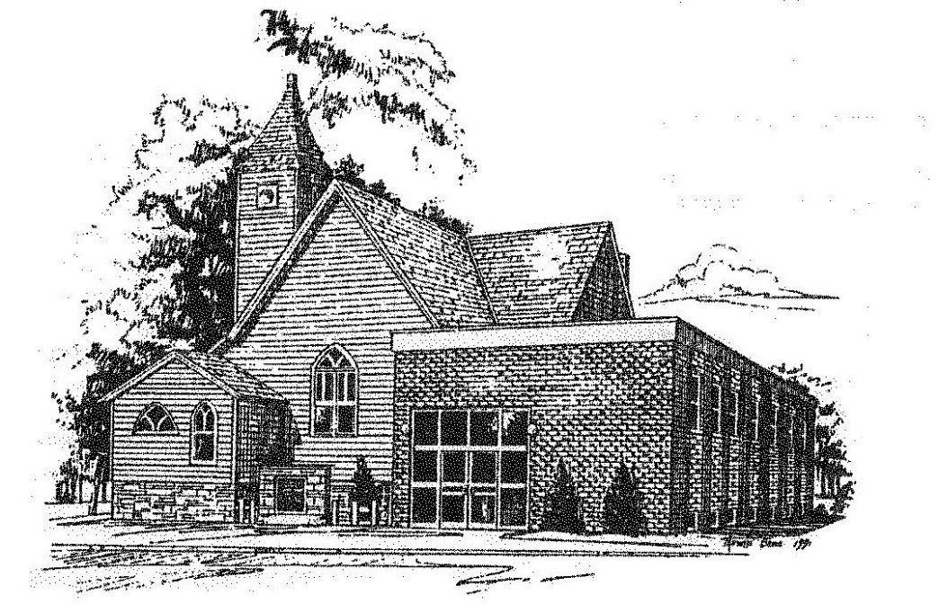

Loving God, Loving People, Making Disciples

Established in Covenant Faithfulness
September 18, 1892
Member of the
Conservative Congregational
Christian Conference
Since 1964

Member of the Conservative Congregational Christian Conference
www.firstcongocobc.com
www.ccccusa.com

