The Worship of Our God
Resting in the Renewing Power of God’s Grace

September 27, 2026 - 9am

Prelude
Welcome
Worship in Song Cleanse Me 92 (P)
The Greatest Thing 240 (P)

Pastoral Prayer, Offertory Prayer & Offering

Worship in Song Trusting Jesus 323 (G)

Reading of the Word Psalm 139

Worship in Word “Comfort in an All-Knowing God”
Pastor Larry Gruis

Worship in Song I Know Who Holds Tomorrow 341 (G)

Benediction

Postlude

Accompanists: Kathi Nelson, Phyllis Shortenhaus
(G) Green hymnal, (P) Purple chorus book (I) Insert

Welcome! We are a gathering of believers in Christ Jesus who desire to love God with all our heart, mind, soul, and strength, to love our neighbors as ourselves, and to make disciples of Christ Jesus.

Faithful in Prayer
Praises & Prayers
- God’s faithfulness in all things
- His grace in preaching, prayer, the sacraments & fellowship
- His powerful & life-giving Word
- Our church family-- individually and collectively; our pastors
- 1G Network and VBS students & families and volunteers
- Emily Silber
- Tim Heitland
- Terry Elman
- Mark Beenken
- Brian Bashans
- Linda & Ron Abels 2680 Old Hwy Rd, Nashua, IA 50658
- Dorothy Berschman
- Duane Kloster 609 2nd St NE, Buffalo Center, IA 50424
- Jim & Dee Kiewiet 304 7th Ave SW, Buffalo Center, IA 50424
- Ivan Dybevik, grandson of Susan Elman Risius
- Jeff Jacobson 87803 245th St, Oakland, MN 56007
- Harold Albrandt, Alicia Burkhow
- TMNH: Kevin Stecker, Phyllis Shortenhaus, Louise Enright
- Bev Heyes
  - Mail: Paul Heyes, Attn: Beverly Heyes, 9148 Creek Way, Savage, MN 55378
- Connie Berhow

Day to Day:
- Opportunities to share the Gospel and the words to say
- Revival in self, Christ’s church, our community, state and country
- Governing authorities & our country
- Wisdom as parents & grandparents committed to raising children in the fear and instruction of the Lord; strong marriages

September Mission Partners: Network Beyond (Steve & Karin Oeffling)

September 30, 3:30pm 1God. This week’s lesson is, “What went wrong? The Sneaky Snake.” This week, we will serve the snack after school and meal at 5:30.

October 4 is world-wide Communion Sunday. We will observe Communion during our worship service.

October 14, Wednesday, 12:00pm Ministerial Association meets in our basement

October 14, Wednesday, 6:30pm Leadership Team meets after 1God cleanup.

November 1, 10:00 to 1:00pm Lakota Ambulance Soup Dinner at the Fire Station (soup, sandwiches, bars & drink). Freewill donation. Could also mail donations to Box 182, Lakota, IA 50451

Pulpit Supply
September 27 Pastor Larry Gruis Cookie Potluck
October 4 Pastor Larry Gruis
World-wide Communion
October 11 Pastor Tim Diehl
October 18 Pastor Larry Gruis Donuts
October 25 Pastor Jeff Griffith Cookie Potluck
November 1 Pastor Larry Gruis Celebrate Kevin’s Bday
November 8 Pastor Tim Diehl
November 15 Pastor Larry Gruis Thanksgiving Potluck
November 22 Pastor Larry Gruis Cookie Potluck
November 29 Pastor Jeff Griffith No coffee time
December 6 Pastor Larry Gruis
December 13 Garth or Trish Boltinghouse Donuts
December 20 Pastor Larry Gruis Cookie Potluck
December 27 Garth or Trish Boltinghouse No coffee time

Contact Information
Pastor Tim Diehl Pastor Jeff Griffith Pastor Larry Gruis
Cell (651) 325-7502 Cell (712) 209-7219 Home (641) 562-2864
diehltim@yahoo.com kralupy@gmail.com ldgruis@yahoo.com

First Congregational Church
Buffalo Center, Iowa

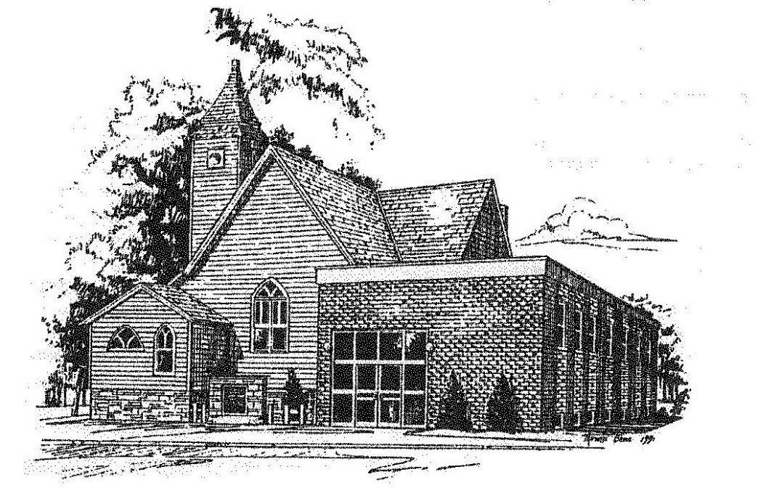

Loving God, Loving People, Making Disciples

Established in Covenant Faithfulness
September 18, 1892
Member of the
Conservative Congregational
Christian Conference
Since 1964

Member of the Conservative Congregational Christian Conference
www.firstcongocobc.com
www.ccccusa.com

