The Worship of Our God
Resting in the Renewing Power of God’s Grace

September 13, 2026 - 9am

Prelude
Welcome
Call to Worship I Will Call Upon the Lord 15 (P)

Pastoral Prayer Lord’s Prayer (trespasses)

Worship in Song When I Look into Your Holiness 40 (P)
Great is the Lord 47 (P)
His Name is Wonderful 52 (P)
Near to the Heart of God 410 (G)

Offertory Prayer & Offering

Worship in Song O Worship the King 28 (G)

Worship in Word Matthew 6:5-18

Worship in the Word “Say What! – Prayer isn’t Powerful?!?!”
Pastor Jeff Griffith

Worship in Song Sweet Hour of Prayer 414 (G)

Benediction

Postlude

Accompanists: Kathi Nelson, Phyllis Shortenhaus
(G) Green hymnal, (P) Purple chorus book (I) Insert

Welcome! We are a gathering of believers in Christ Jesus who desire to love God with all our heart, mind, soul, and strength, to love our neighbors as ourselves, and to make disciples of Christ Jesus.

Faithful in Prayer
Praises & Prayers
- God’s faithfulness in all things
- His grace in preaching, prayer, the sacraments & fellowship
- His powerful & life-giving Word
- Our church family-- individually and collectively; our pastors
- 1G Network and VBS students & families and volunteers
- Pastor Larry, Becky & Shauna Gruis in the passing of his sister, Sharen Roth, August 27th
- Tim Heitland (home)
- Terry Elman (home)
- Brian Bashans
- Linda & Ron Abels 2680 Old Hwy Rd, Nashua, IA 50658
- Dorothy Berschman
- Duane Kloster 609 2nd St NE, Buffalo Center, IA 50424
- Jim & Dee Kiewiet 304 7th Ave SW, Buffalo Center, IA 50424
- Ivan Dybevik, grandson of Susan Elman Risius
- Jeff Jacobson 87803 245th St, Oakland, MN 56007
- Harold Albrandt, Alicia Burkhow
- TMNH: Kevin Stecker, Phyllis Shortenhaus, Louise Enright
- Bev Heyes
  - Mail: Paul Heyes, Attn: Beverly Heyes, 9148 Creek Way, Savage, MN 55378
- Connie Berhow

Day to Day:
- Opportunities to share the Gospel and the words to say
- Revival in self, Christ’s church, our community, state and country
- Governing authorities & our country
- Wisdom as parents & grandparents committed to raising children in the fear and instruction of the Lord; strong marriages

September Mission Partners: Network Beyond (Steve & Karin Oeffling)

September 16, 3:30pm 1God meets here! We are learning about Old Testament accounts this year, starting with, “Creation” this week. It appears that we will be down nine volunteers on Wednesday. If you could assist in any way, we’d sure appreciate the help!

November 1, 10:00 to 1:00pm Lakota Ambulance Soup Dinner at the Fire Station (soup, sandwiches, bars & drink). Freewill donation. Could also mail donations: Box 182, Lakota, IA 50451

Christian love and sympathy to Pastor Larry, Becky and Shauna at the passing of Larry’s sister, Sharen Roth, on August 27th. Services were held Friday at the First Baptist Church in Waukon. May God’s comfort and peace continue to support you through this time.

Thank you all for your thoughts, texts, and many prayers for me during my recent hospitalization and since my return home. God is good in all things! Tim Heitland

Pulpit Supply
September 13 Pastor Jeff Griffith Kathi
September 20 Garth or Trish Boltinghouse Donuts
September 27 Pastor Larry Gruis Cookie Potluck
October 4 Pastor Larry Gruis
World-wide Communion
October 11 Pastor Tim Diehl
October 18 Pastor Larry Gruis Donuts
October 25 Pastor Jeff Griffith Cookie Potluck
November 1 Pastor Larry Gruis Celebrate Kevin’s Bday
November 8 Pastor Tim Diehl
November 15 Pastor Larry Gruis Thanksgiving Potluck
November 22 Pastor Larry Gruis Cookie Potluck
November 29 Pastor Jeff Griffith No coffee time
December 6 Pastor Larry Gruis
December 13 Garth or Trish Boltinghouse Donuts
December 20 Pastor Larry Gruis Cookie Potluck
December 27 Garth or Trish Boltinghouse No coffee time

Contact Information
Pastor Tim Diehl Pastor Jeff Griffith Pastor Larry Gruis
Cell (651) 325-7502 Cell (712) 209-7219 Home (641) 562-2864
diehltim@yahoo.com kralupy@gmail.com ldgruis@yahoo.com

First Congregational Church
Buffalo Center, Iowa

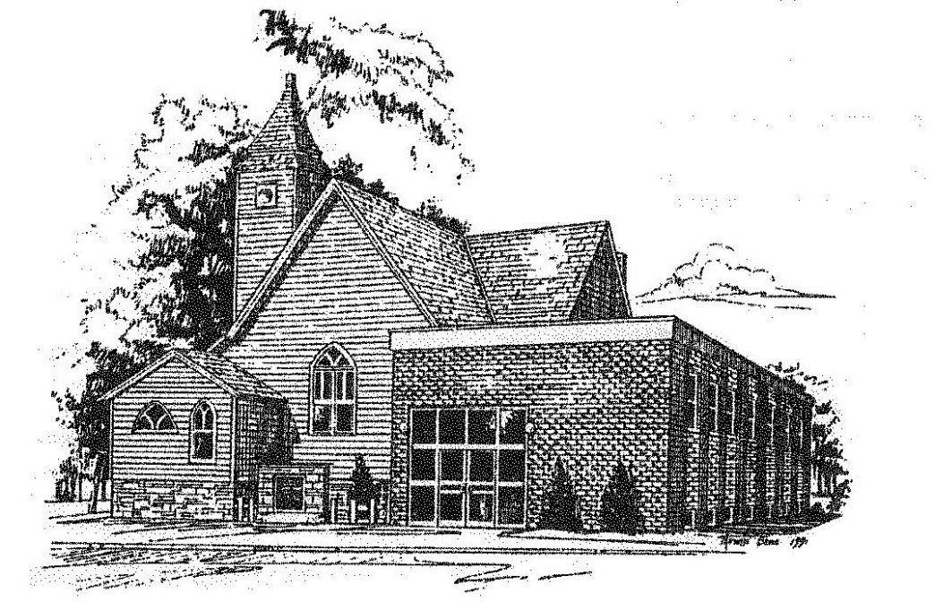

Loving God, Loving People, Making Disciples

Established in Covenant Faithfulness
September 18, 1892
Member of the
Conservative Congregational
Christian Conference
Since 1964

Member of the Conservative Congregational Christian Conference
www.firstcongocobc.com
www.ccccusa.com

