The Worship of Our God
Resting in the Renewing Power of God’s Grace

August 30, 2026 - 9am

Prelude
Welcome
Call to Worship

Worship in Song Great is the Lord 47 (P)
Thou Art Worthy 109 (P)

Invocation

Worship in Song Lamb of God 7 (P)

Pastoral Prayer, Offertory Prayer & Offering

Worship in Song Where the Spirit of the Lord Is 115 (P)

Reading of the Word Mark 2:23 - 3:6

Worship in the Word “…”
Pastor Tim Diehl

Worship in Song Shine, Jesus, Shine 259 (P)

Benediction

Postlude

Accompanists: Kathi Nelson, Phyllis Shortenhaus
(G) Green hymnal, (P) Purple chorus book (I) Insert

Welcome! We are a gathering of believers in Christ Jesus who desire to love God with all our heart, mind, soul, and strength, to love our neighbors as ourselves, and to make disciples of Christ Jesus.

Faithful in Prayer
Praises & Prayers
- God’s faithfulness in all things
- His grace in preaching, prayer, the sacraments & fellowship
- His powerful & life-giving Word
- Our church family-- individually and collectively; our pastors
- 1G Network and VBS students & families and volunteers
- Tim Heitland (hospitalized, surgery this past week)
- Terry Elman (hospitalized, surgery this past week)
- Brian Bashans
- Linda & Ron Abels 2680 Old Hwy Rd, Nashua, IA 50658
- Bev Adams
- Dorothy Berschman
- Duane Kloster 609 2nd St NE, Buffalo Center, IA 50424
- Jim & Dee Kiewiet 304 7th Ave SW, Buffalo Center, IA 50424
- Ivan Dybevik, grandson of Susan Elman Risius
- Jeff Jacobson 87803 245th St, Oakland, MN 56007
- Harold Albrandt, Alicia Burkhow
- TMNH: Kevin Stecker, Phyllis Shortenhaus, Louise Enright
- Bev Heyes
  - Mail: Paul Heyes, Attn: Beverly Heyes, 9148 Creek Way, Savage, MN 55378
- Connie Berhow

Day to Day:
- Opportunities to share the Gospel and the words to say
- Revival in self, Christ’s church, our community, state and country
- Governing authorities & our country
- Wisdom as parents & grandparents committed to raising children in the fear and instruction of the Lord; strong marriages

August Mission Partners: Brian & Jeleta Eckheart

September 9, 3:30pm 1God begins for 2026-27 school year!

September 9, 6:30pm (right after 1God) Leadership Team Meeting

September 17: We are putting together a group to go to the Cities to visit with Bev Heyes. We would leave about 8:30 or 9am, travel to the Cities, have lunch, visit Bev (and have coffee) for an hour or so and then head home. This date is just a place to start and we can be flexible. If you are interested in being a part of this, please talk with Kathi. (641) 860-1161.

Thank you! Thank you for my 81st birthday party. Made me feel very special. God’s blessings to all who helped. God bless you all. Louise Enright

Pulpit Supply
August 30 Pastor Tim Diehl
September 6 Pastor Larry Gruis
September 13 Pastor Jeff Griffith Coffee time resumes
September 20 Garth or Trish Boltinghouse
September 27 Pastor Larry Gruis Cookie Potluck
October 4 Pastor Larry Gruis
World-wide Communion
October 11 Pastor Tim Diehl
October 18 Pastor Larry Gruis
October 25 Pastor Jeff Griffith
November 1 Pastor Larry Gruis Celebrate Kevin’s Bday!
November 8 Pastor Tim Diehl
November 15 Pastor Larry Gruis Thanksgiving Potluck
November 22 Pastor Larry Gruis
November 29 Pastor Jeff Griffith
December 6 Pastor Larry Gruis
December 13 Garth or Trish Boltinghouse
December 20 Pastor Larry Gruis
December 27 Garth or Trish Boltinghouse

Contact Information
Pastor Tim Diehl Pastor Jeff Griffith Pastor Larry Gruis
Cell (651) 325-7502 Cell (712) 209-7219 Home (641) 562-2864
diehltim@yahoo.com kralupy@gmail.com ldgruis@yahoo.com

First Congregational Church
Buffalo Center, Iowa

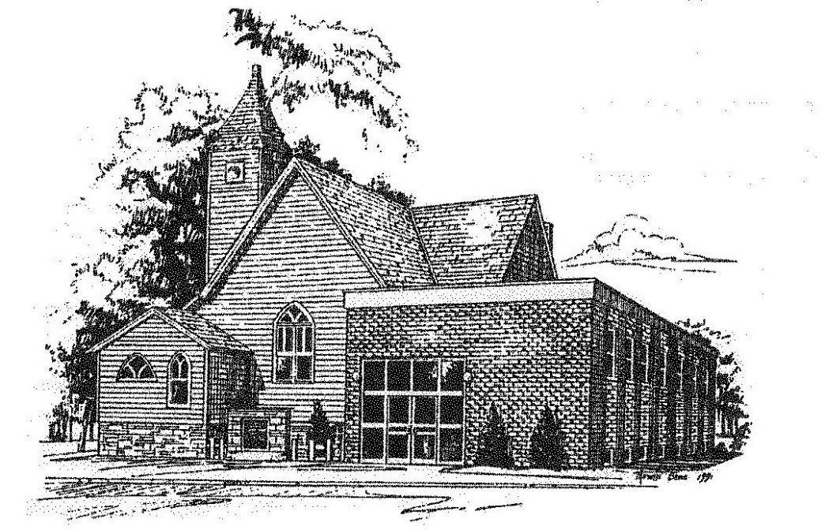

Loving God, Loving People, Making Disciples

Established in Covenant Faithfulness
September 18, 1892
Member of the
Conservative Congregational
Christian Conference
Since 1964

Member of the Conservative Congregational Christian Conference
www.firstcongocobc.com
www.ccccusa.com

