The Worship of Our God
Resting in the Renewing Power of God’s Grace

August 16, 2026 - 9am

Prelude
Welcome
Call to Worship

Worship in Song This is the Day 85 (P)
Majesty 98 (P)

Pastoral Prayer

Offertory Prayer & Offering

Worship in Song Glorify Thy Name 13 (P)

Worship in Word John 4:23-24

Worship in Word “Worship”
Pastor Larry Gruis

Worship in Song Wonderful Grace of Jesus 291 (G)

Benediction

Postlude

Accompanists: Kathi Nelson, Phyllis Shortenhaus
(G) Green hymnal, (P) Purple chorus book (I) Insert

Welcome! We are a gathering of believers in Christ Jesus who desire to love God with all our heart, mind, soul, and strength, to love our neighbors as ourselves, and to make disciples of Christ Jesus.

Faithful in Prayer
Praises & Prayers
- God’s faithfulness in all things
- His grace in preaching, prayer, the sacraments & fellowship
- His powerful & life-giving Word
- Our church family-- individually and collectively; our pastors
- 1G Network and VBS students & families and volunteers
- Brian Bashans
- Linda & Ron Abels
2680 Old Hwy Rd, Nashua, IA 50658
- Bev Adams
- Dorothy Berschman
- Duane Kloster 609 2nd St NE, Buffalo Center, IA 50424
- Jim & Dee Kiewiet 304 7th Ave SW, Buffalo Center, IA 50424
- Ivan Dybevik, grandson of Susan Elman Risius
- Jeff Jacobson 87803 245th St, Oakland, MN 56007
- Harold Albrandt, Alicia Burkhow
- TMNH: Kevin Stecker, Phyllis Shortenhaus, Louise Enright
- Bev Heyes
  - Mail: Paul Heyes, Attn: Beverly Heyes, 9148 Creek Way, Savage, MN 55378
- Connie Berhow

Day to Day:
- Opportunities to share the Gospel and the words to say
- Revival in self, Christ’s church, our community, state and country
- Governing authorities & our country
- Wisdom as parents & grandparents committed to raising children in the fear and instruction of the Lord; strong marriages

August Mission Partners: Brian & Jeleta Eckheart

It’s time! August 22 Myrth Ugland will celebrate her 90th birthday with a party in Colorado. Since most of us can’t make that, please celebrate by sending a card to her:
Myrth Ugland,
9307 Stoneglen Dr.
Colorado Springs, CO 80920

September 9, 3:30pm 1God begins for 2026-27 school year!

September 9, 6:30pm (right after 1God) Leadership Team Meeting

September 17: We are putting together a group to go to the Cities to visit with Bev Heyes. We would leave about 8:30 or 9am, travel to the Cities, have lunch, visit Bev (and have coffee) for an hour or so and then head home. This date is just a place to start and we can be flexible. If you are interested in being a part of this, please talk with Kathi. (641) 860-1161.

Pulpit Supply
August 16 Pastor Larry Gruis
August 23 Garth or Trish Boltinghouse
August 30 Pastor Tim Diehl
September 6 Pastor Larry Gruis
September 13 Pastor Jeff Griffith Coffee time resumes
September 20 Garth or Trish Boltinghouse
September 27 Pastor Larry Gruis Cookie Potluck
October 4 Pastor Larry Gruis
World-wide Communion
October 11 Pastor Tim Diehl
October 18 Pastor Larry Gruis
October 25 Pastor Jeff Griffith
November 1 Pastor Larry Gruis
November 8 Pastor Tim Diehl
November 15 Pastor Larry Gruis
November 22 Pastor Larry Gruis
November 29 Pastor Jeff Griffith

Contact Information
Pastor Tim Diehl Pastor Jeff Griffith Pastor Larry Gruis
Cell (651) 325-7502 Cell (712) 209-7219 Home (641) 562-2864
diehltim@yahoo.com kralupy@gmail.com ldgruis@yahoo.com

First Congregational Church
Buffalo Center, Iowa

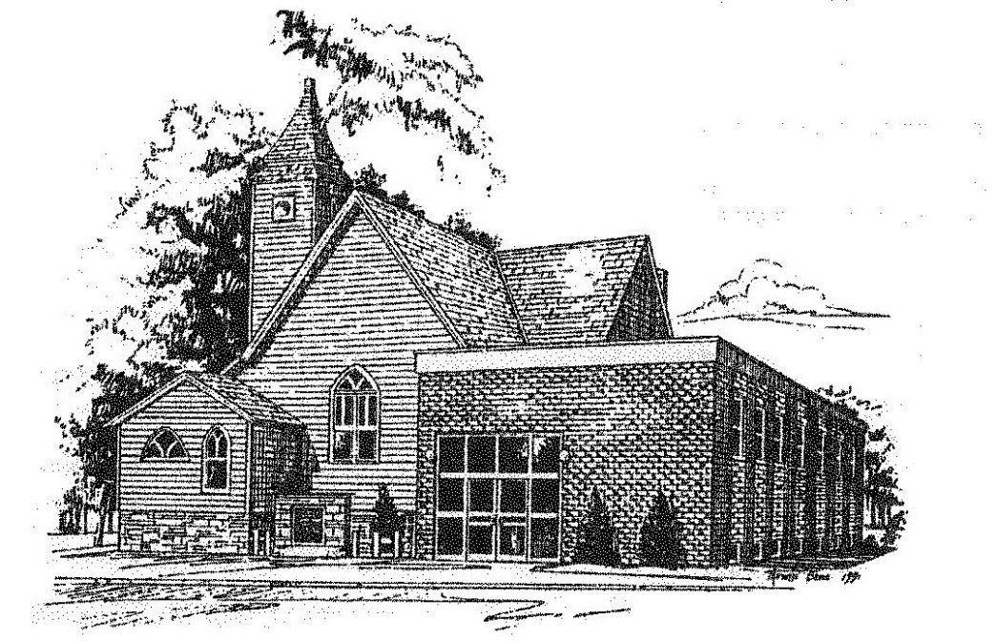

Loving God, Loving People, Making Disciples

Established in Covenant Faithfulness
September 18, 1892
Member of the
Conservative Congregational
Christian Conference
Since 1964

Member of the Conservative Congregational Christian Conference
www.firstcongocobc.com
www.ccccusa.com

