The Worship of Our God
Resting in the Renewing Power of God’s Grace

August 9, 2026 - 9am

Prelude
Welcome
Call to Worship

Worship in Song To God Be the Glory 8 (G)

Offertory Prayer & Offering

Worship in Song All Creatures of Our God and King 37 (G)

Worship in Word Jeremiah 17:14

Worship in Word “YOU Are My Praise”
Trish Boltinghouse

Worship in Song Praise Him! Praise Him! 63 (G)

Benediction

Postlude

Accompanists: Kathi Nelson, Phyllis Shortenhaus
(G) Green hymnal, (P) Purple chorus book (I) Insert

Welcome! We are a gathering of believers in Christ Jesus who desire to love God with all our heart, mind, soul, and strength, to love our neighbors as ourselves, and to make disciples of Christ Jesus.

Faithful in Prayer
Praises & Prayers
- God’s faithfulness in all things
- His grace in preaching, prayer, the sacraments & fellowship
- His powerful & life-giving Word
- Our church family-- individually and collectively; our pastors
- 1G Network and VBS students & families and volunteers
- Terry Elman
- Brian Bashans
- Linda & Ron Abels
2680 Old Hwy Rd, Nashua, IA 50658
- Bev Adams
- Dorothy Berschman
- Duane Kloster 609 2nd St NE, Buffalo Center, IA 50424
- Jim & Dee Kiewiet 304 7th Ave SW, Buffalo Center, IA 50424
- Ivan Dybevik, grandson of Susan Elman Risius
- Jeff Jacobson 87803 245th St, Oakland, MN 56007
- Harold Albrandt, Alicia Burkhow
- TMNH: Kevin Stecker, Phyllis Shortenhaus, Louise Enright
- Bev Heyes
  - Mail: Paul Heyes, Attn: Beverly Heyes, 9148 Creek Way, Savage, MN 55378
- Connie Berhow

Day to Day:
- Opportunities to share the Gospel and the words to say
- Revival in self, Christ’s church, our community, state and country
- Governing authorities & our country
- Wisdom as parents & grandparents committed to raising children in the fear and instruction of the Lord; strong marriages

August Mission Partners: Brian & Jeleta Eckheart

Today! 10am Birthday coffee for Louise Enright at TMNH. We need to wind things up at 10:30 to 10:40 to allow for their 11:30 noon meal set up. Join us!!!

August 12, Wednesday, 7pm Leadership Team Meeting

August 22 Myrth Ugland will celebrate her 90th birthday with a party in Colorado. Since most of us can’t make that, please celebrate by sending a card to her:
Myrth Ugland,
9307 Stoneglen Dr.
Colorado Springs, CO 80920

September 10, 3:30pm 1God begins for 2026-27 school year!

Pulpit Supply
August 9 Trish Boltinghouse
Birthday coffee with Louise at TMNH
August 16 Pastor Larry Gruis
August 23 Garth or Trish Boltinghouse
August 30 Pastor Tim Diehl
September 6 Pastor Larry Gruis
September 13 Pastor Jeff Griffith Coffee time resumes
September 20 Garth or Trish Boltinghouse
September 27 Pastor Larry Gruis Cookie Potluck
October 4 Pastor Larry Gruis
World-wide Communion
October 11 Pastor Tim Diehl
October 18 Pastor Larry Gruis
October 25 Pastor Jeff Griffith
November 1 Pastor Larry Gruis
November 8 Pastor Tim Diehl
November 15 Pastor Larry Gruis
November 22 Pastor Larry Gruis
November 29 Pastor Jeff Griffith

Contact Information
Pastor Tim Diehl Pastor Jeff Griffith Pastor Larry Gruis
Cell (651) 325-7502 Cell (712) 209-7219 Home (641) 562-2864
diehltim@yahoo.com kralupy@gmail.com ldgruis@yahoo.com

First Congregational Church
Buffalo Center, Iowa

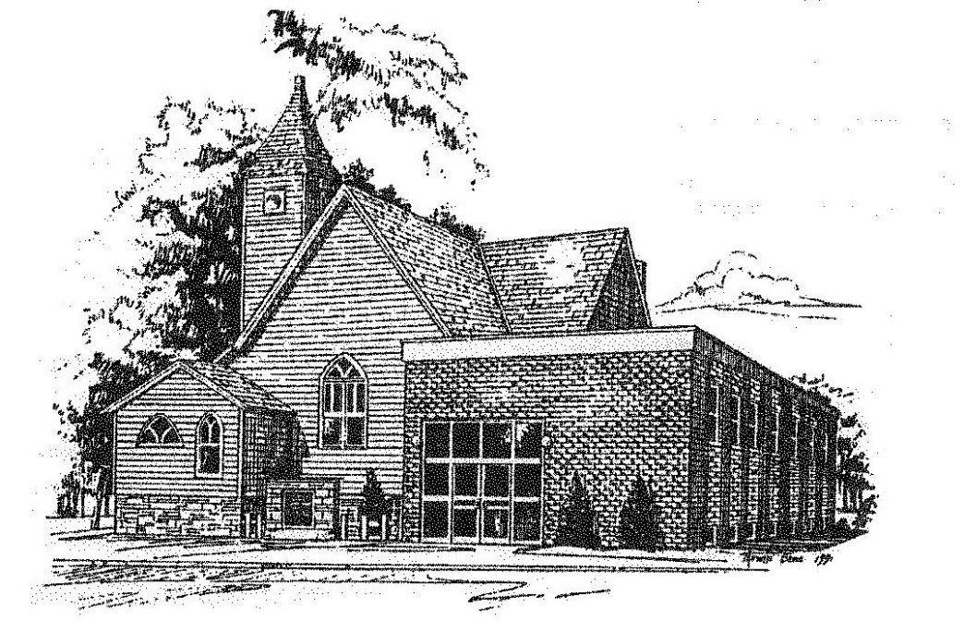

Loving God, Loving People, Making Disciples

Established in Covenant Faithfulness
September 18, 1892
Member of the
Conservative Congregational
Christian Conference
Since 1964

Member of the Conservative Congregational Christian Conference
www.firstcongocobc.com
www.ccccusa.com

